NISSAN PATROL CRD EGR DELETE

Tools Needed
- Socket set
- Screw driver
- Brake cleaner

Part 1.
Pull engine cover and Intercooler off
Unplug the Map sensor carefully please
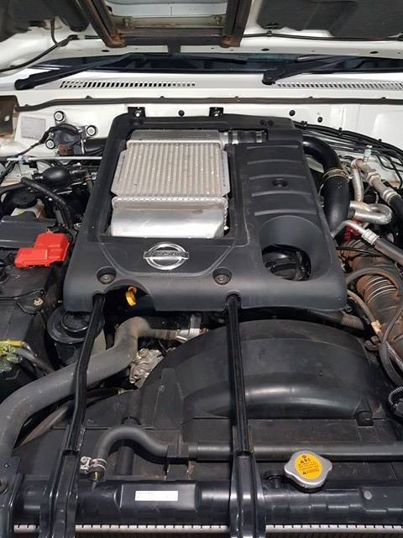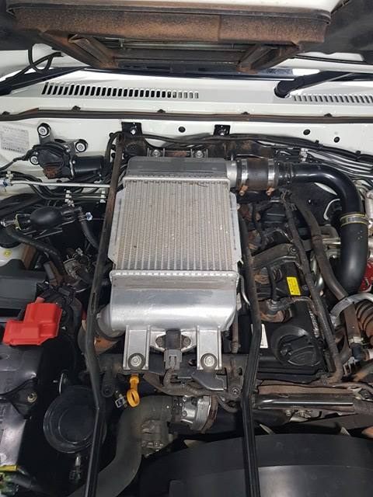

Part 2.
Undo the 2x 12mm bolts that are marked in white
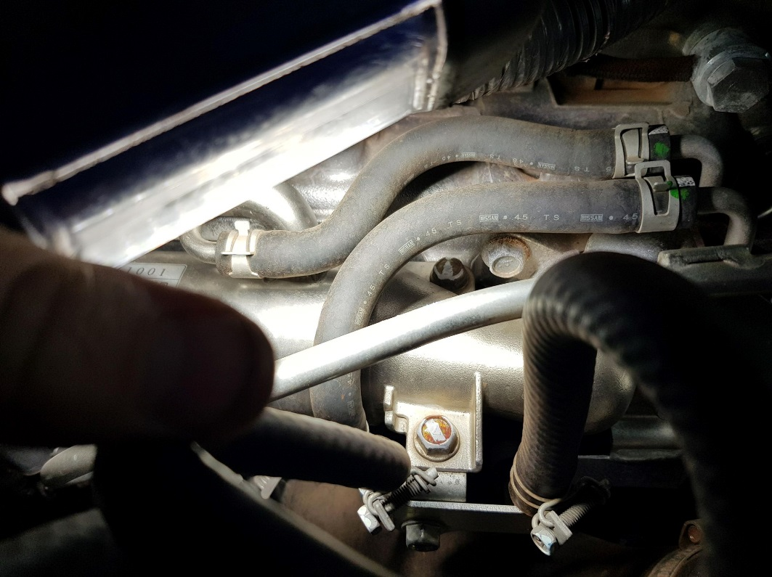

Part 3.
Undo the 2x 12mm bolts on the EGR flange
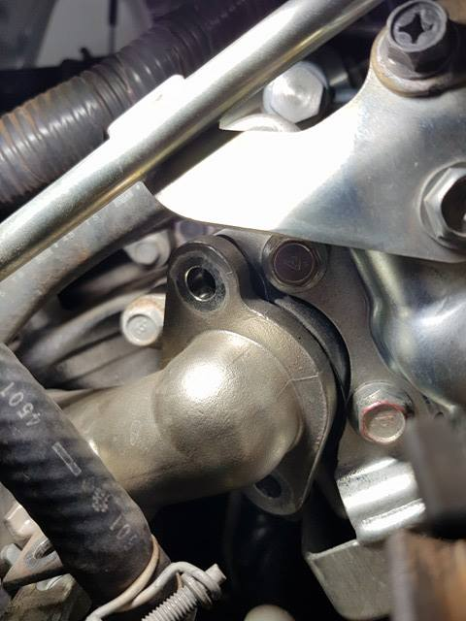
Part 4.

Manipulate the pipe a little to give you some room to pull the gasket out and slide the EGR plate in.
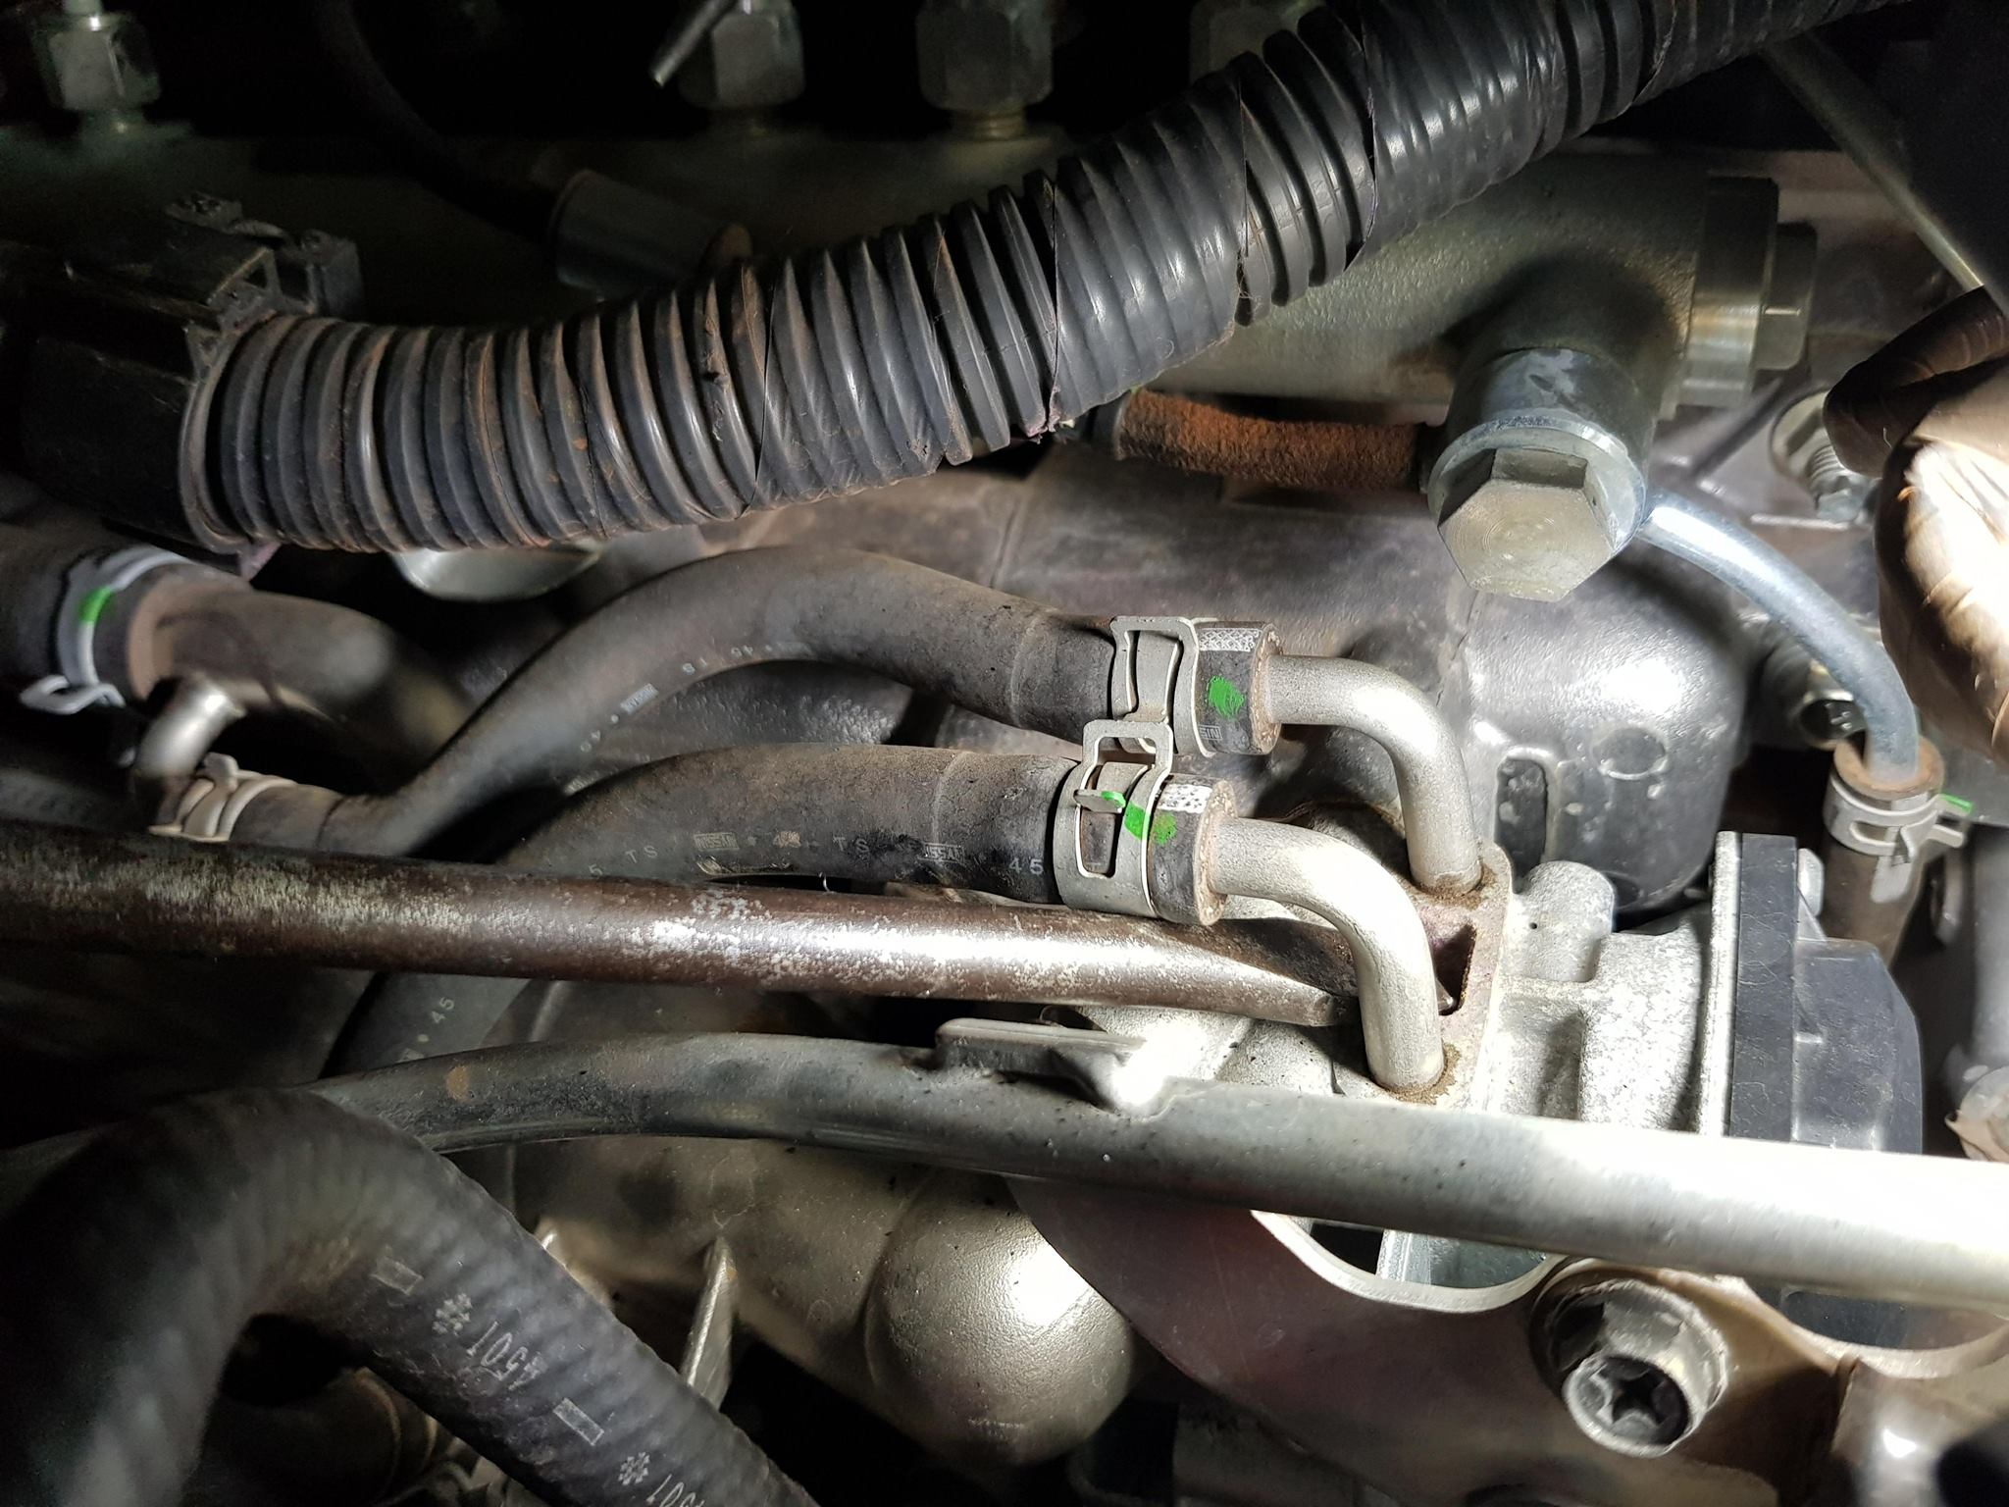
Once you have put the plate in you can now put the 2x 12mm bolts but into the flange
You can now put the 2x 12mm bolts back onto the EGR cooler
PHOTO IN NEXT PAGE

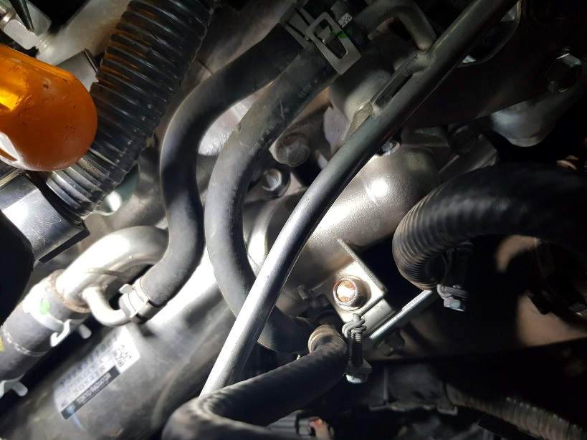

Part 5.
Clean the intercooler pipes where the cooler fits into
Clean the intercooler pipe end
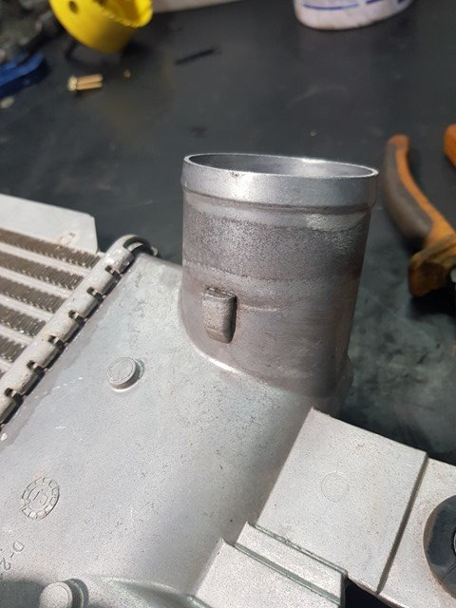
this will stop the pipe from coming off

Part 6.
Fit engine cover but onto car
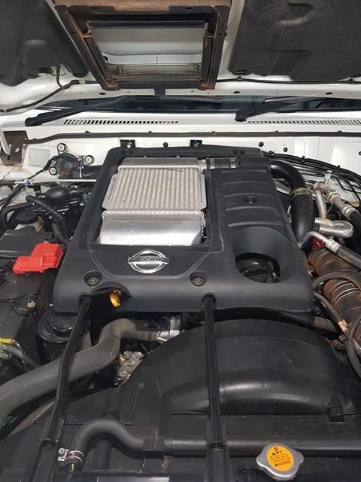

Part 7.

Fit the Supplied wiring loom onto the Maf sensor on the airbox

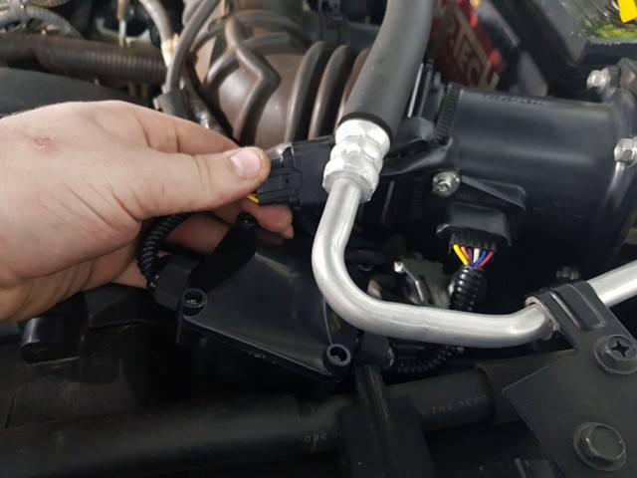
Now you are all done
Start the car and check for engine lights

Any questions please call

(07) 49530040

Facebook
Diesel Smart Performance Products

www.dieselsmart.com.au

Thanks For your Business

