Nissan Patrol Non Common Rail (Direct Injection)
!WARNING!
Failure to correctly install this Diesel Smart Module may result in permanent damage to your engine.
Before attempting to install your Diesel Smart Module please read and make sure you understand the instructions provided.
If you are unsure of what you are about to undertake, please get your local Diesel Smart dealer, auto electrician or mechanic to install this Diesel Smart Module for you if you don’t feel confident yourself.
DO NOT PLUG FUSE INTO HARNESS OR TURN CAR ON UNTIL ALL PLUGS, INCLUDING THE + AND –, AND THE MODULE MUST BE CONNECTED TO THE LOOM AND TIGHTENED! FAILURE TO DO SO WILL DESTROY THE CIRCUIT BOARD; THIS WILL NOT BE CONSIDERED TO BE A WARRANTY CLAIM.
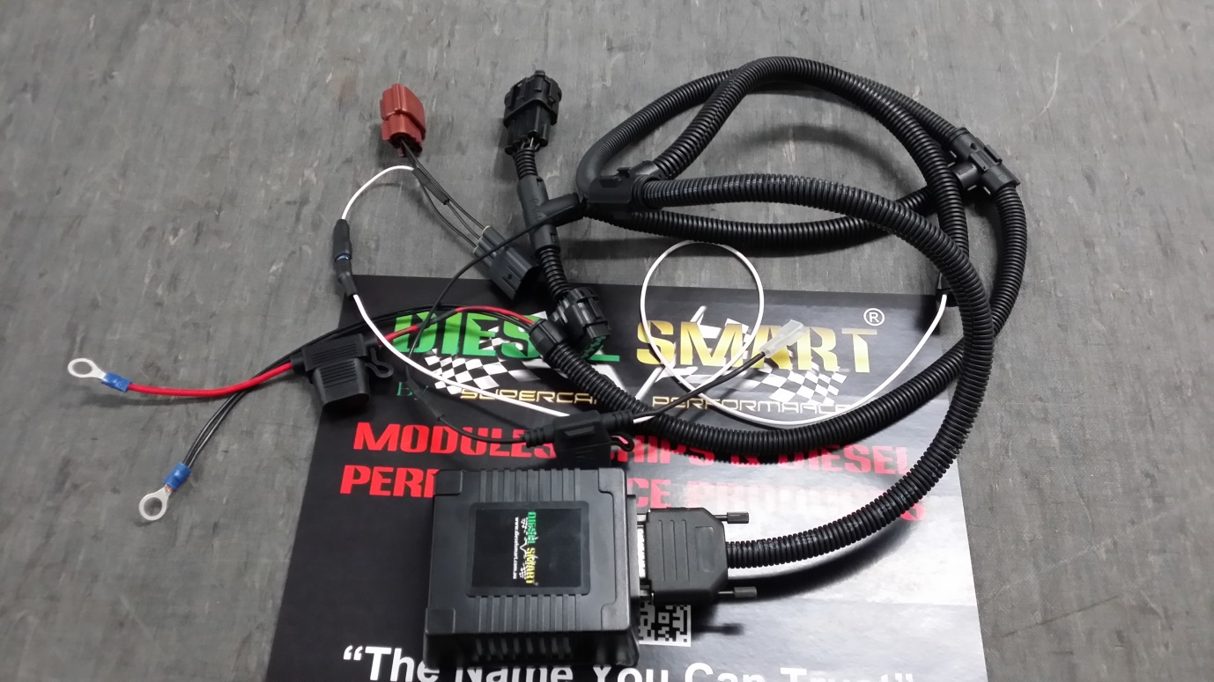

1. Remove key from the ignition and place on top of the dash
2. Remove nuts from engine cover and remove engine cover. (Not necessary, but some find it easier to get down to the pump area)
3. Locate the injector pump on the driver side of engine. You will need to crimp on a connector to the outside wire on the pump (closest to the driver side tyre). There are only 2 black wires here.
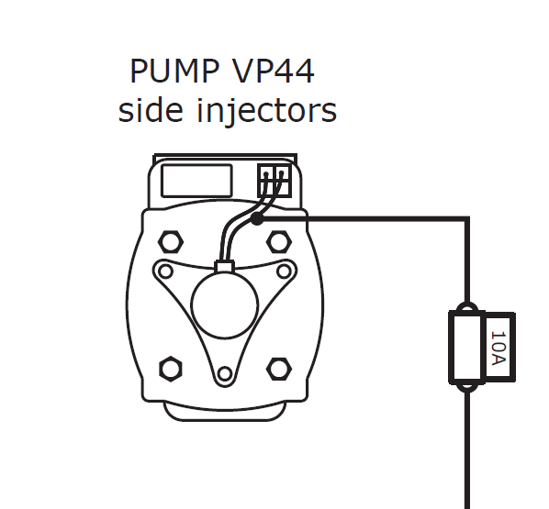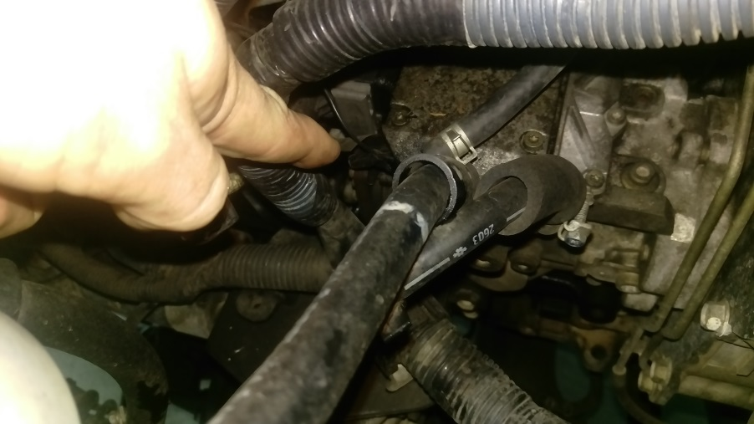
*The black and white diagram above is the rear view of the pump.
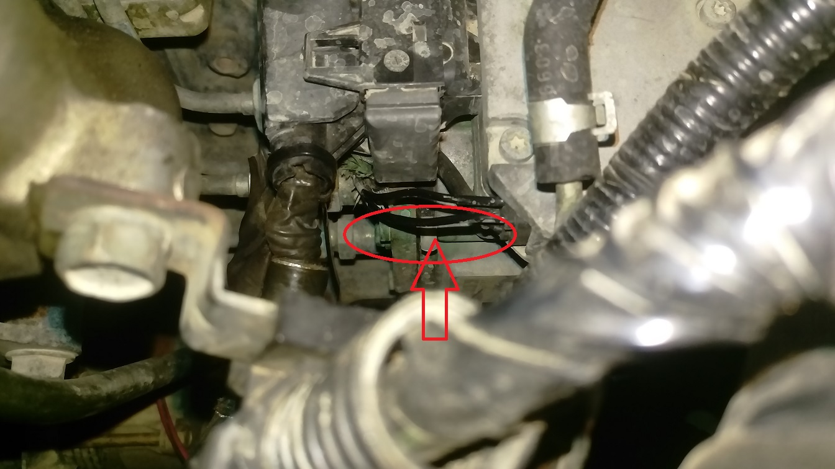

4. Using a pair of small pointy nose pliers, crimp on the terminal to the outside wire on the back of the pump. This may be a little tricky, as there is not much space down there. While crimping the terminal, you will hear a slight *click* noise, this is a sign the terminal has crimped and locked on. Ensure the terminal has crimped on firmly, by giving it a gentle wiggle with your fingers. (This wire can also be soldered to the black wire if you do not wish to use the supplied crimp terminal. But make sure you insulate with electrical tape after soldering)
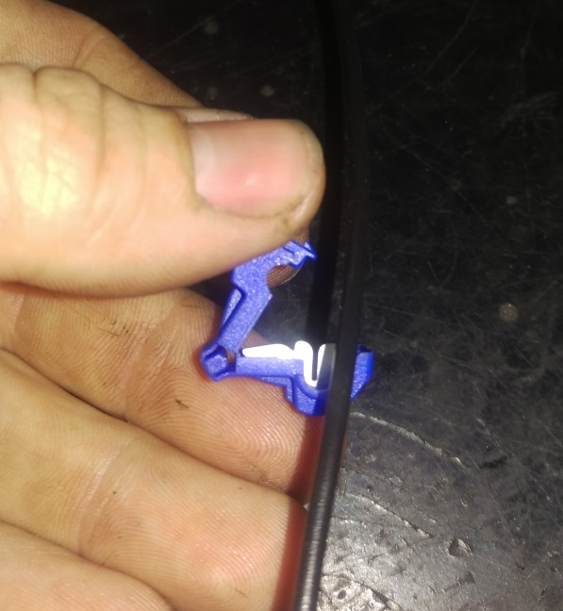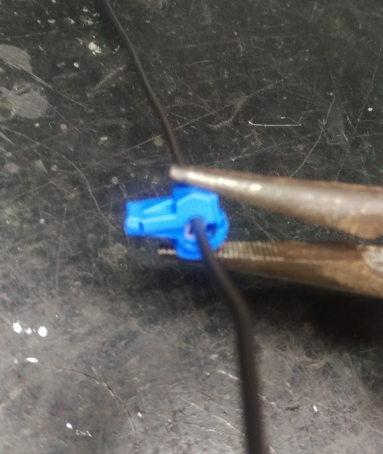

4a. Now plug in the single black wire with fuse into the blue crimped terminal.
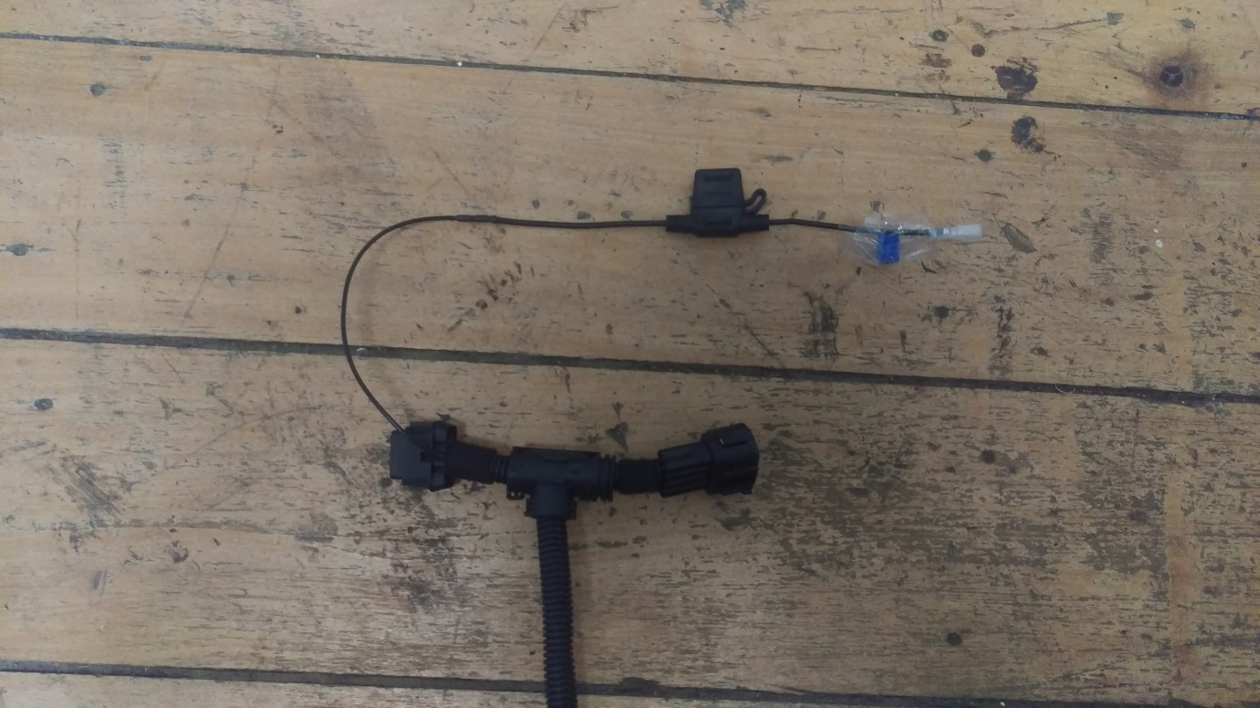

5. Now locate the black 8 pin plug above the pump. It is next to a grey plug. Un-plug this black plug and T module harness in between the original plugs.
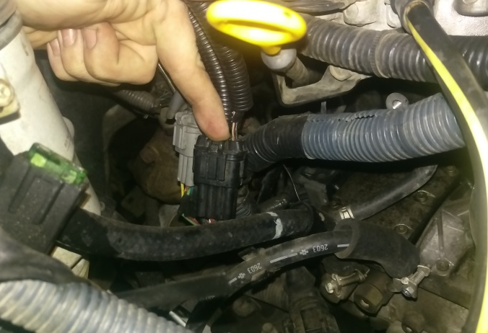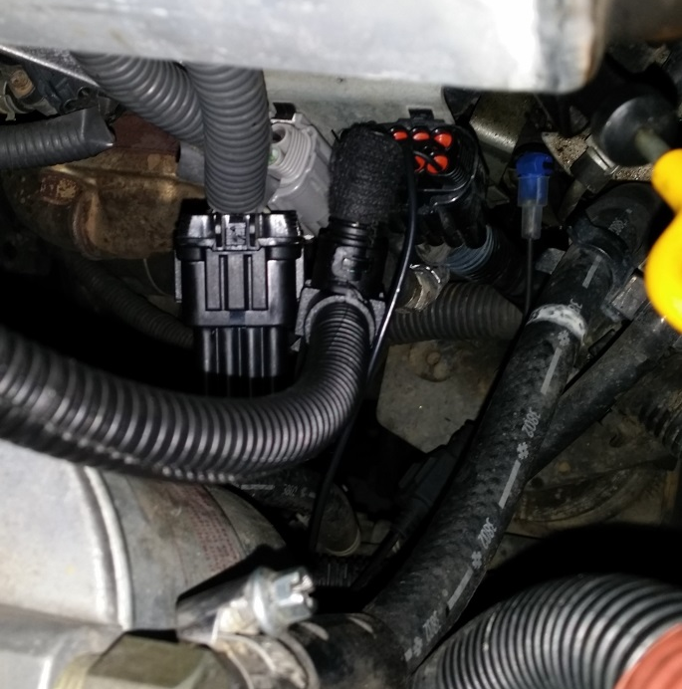

6. You will need to find a rubber grommet on the firewall of your engine bay. On this car, it is located on the driver side. It has the main wiring harness go through into the cabin of the vehicle. Or preferably, a small grommet away from the main wiring loom. Once you have found the grommet, you now cut a small hole with a sharp knife or razorblade for the harness to push through. Carefully wrap the wires with electrical tape around a small plastic or steel wire (Eg. Coat hanger or something similar) carefully fed through the grommet. If you use the main wiring harness grommet, be careful not to cut/chaff/pierce or short any wires as you route the wiring harness through, as this may short out and can cause damage to the ECU or vehicle. Attach the single white to the pull through cable or other suitable means and pull it through into the foot well. (Accelerator pedal)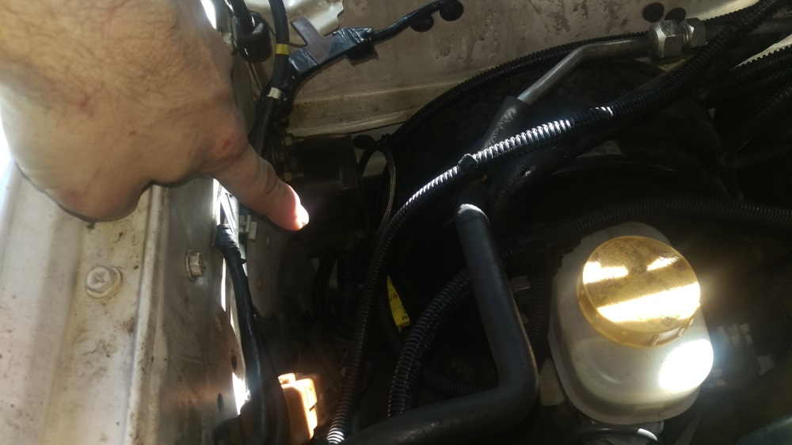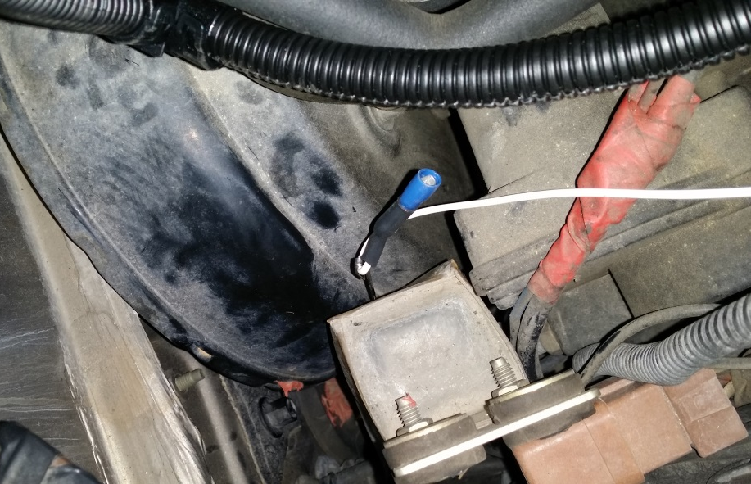
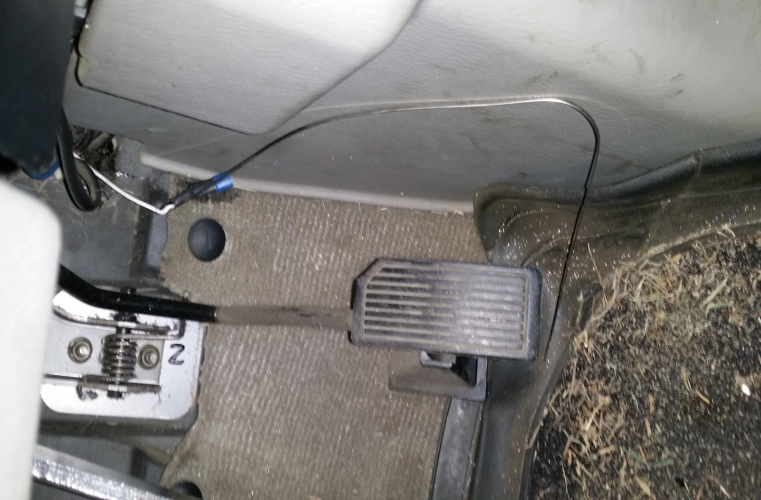
7. Once this is pulled through, you now plug in the throttle position harness onto the accelerator pedal. (Brown plug). Then plug the single white wire to this harness.
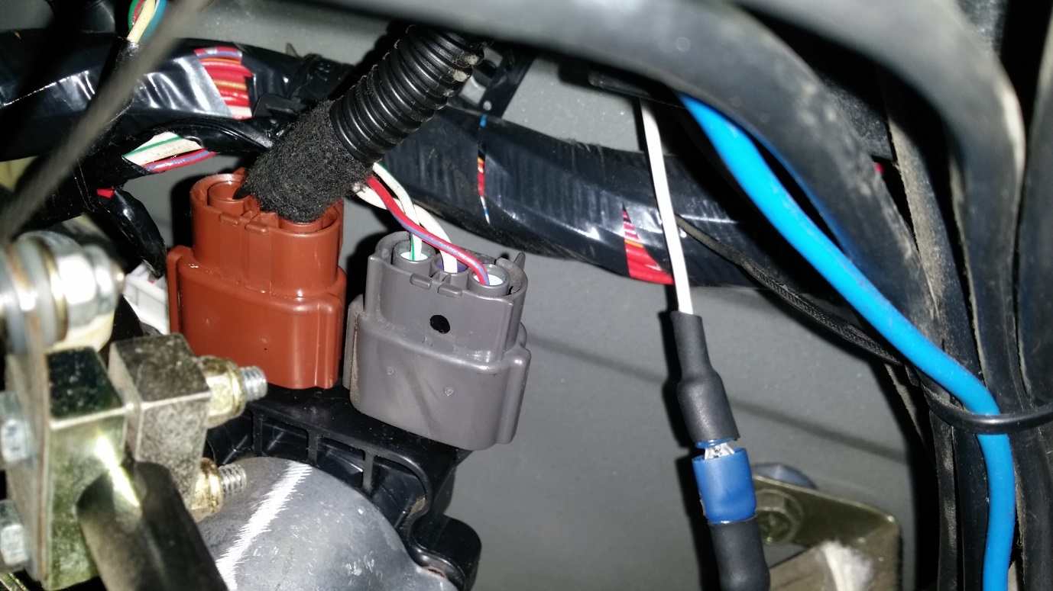
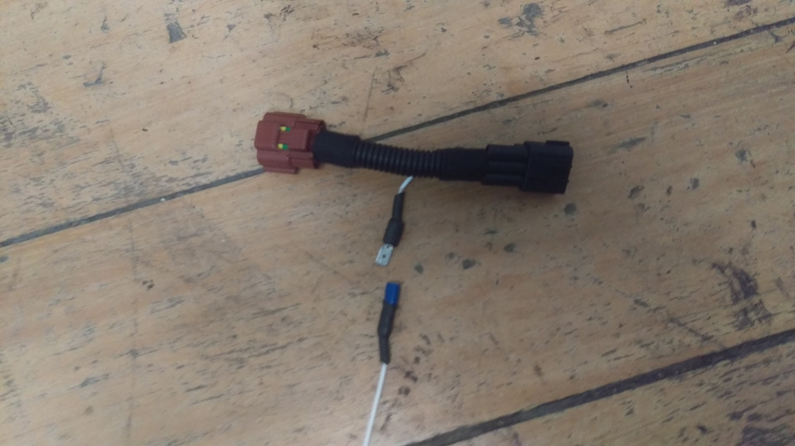

8. Now connect the positive and negative wires to the battery terminals, making sure the fuse is not in the fuse holder.
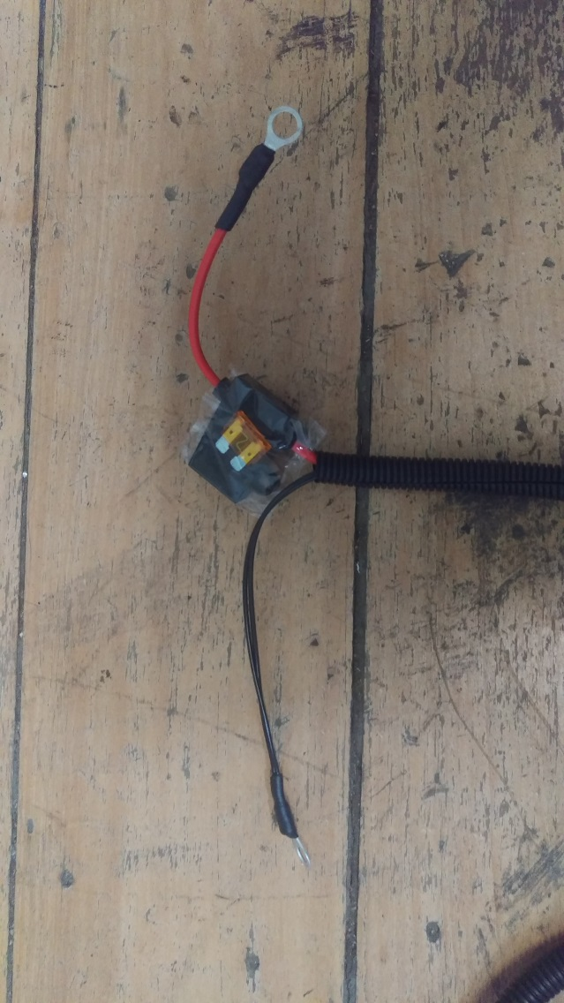

9. Find a suitable location away from heat and as high as possible in the engine bay on the opposite side of the exhaust to mount the module to the engine bay with the Velcro that has been supplied. Before sticking Velcro to surface please clean with a solvent to make sure the surface is cleaned properly. Velcro is used to stop vibration traveling into the board and shortening the life of the electronics within it.
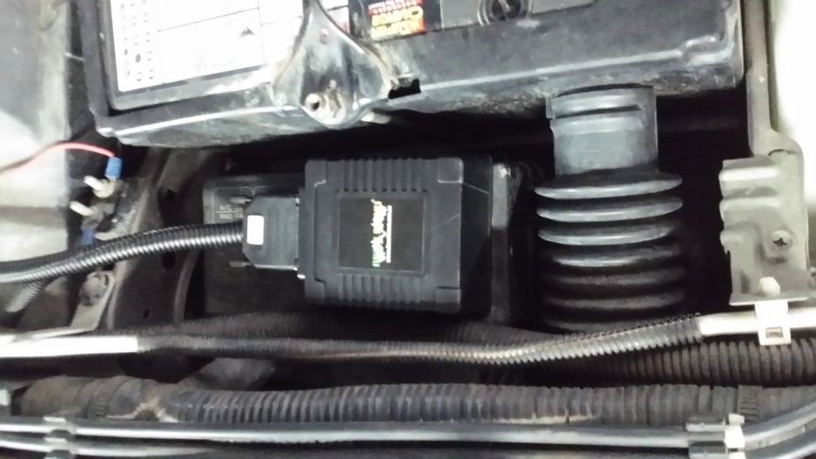
10. Once you have double checked all connections are firm, you can now put in the fuse into the battery fuse holder. Place key into the ignition and start vehicle, make sure that the vehicle is idling normally. Rev the vehicle in a stationary position before driving the vehicle and make sure that the engine revs freely. Check your dash to make sure there are no check lights on the dash before driving car. Once this has been completed the car is ready to drive. If you are unsure if it is operating correctly you must contact diesel smart immediately and speak to one of our technicians.
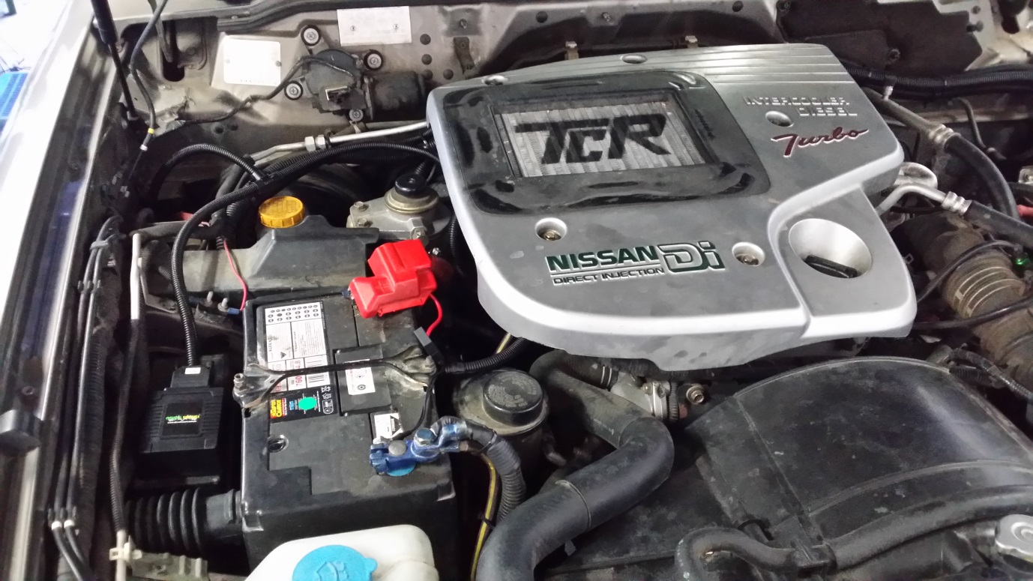

• IF YOU DO NOT UNDERSTAND ANY OF THESE INSTRUCTIONS PLEASE CALL US ON
07 49530040 FOR FURTHER ASSISTANCE.

