ECU TORQUE SYSTEM

Before carrying out any of the following, remove the keys from the ignition, and place them out of the way. Do not put your keys back into the ignition until the whole wiring system has been completely fitted correctly.

First you will need to remove your engine cover as well as your intercooler
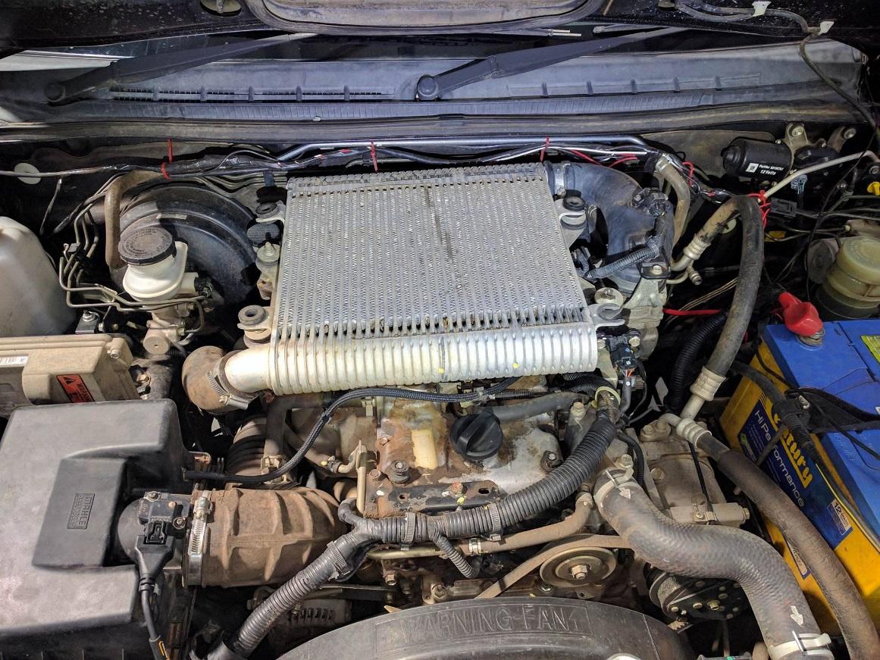
Most intercoolers will be held on by 4 bolts and 2 hose clamps
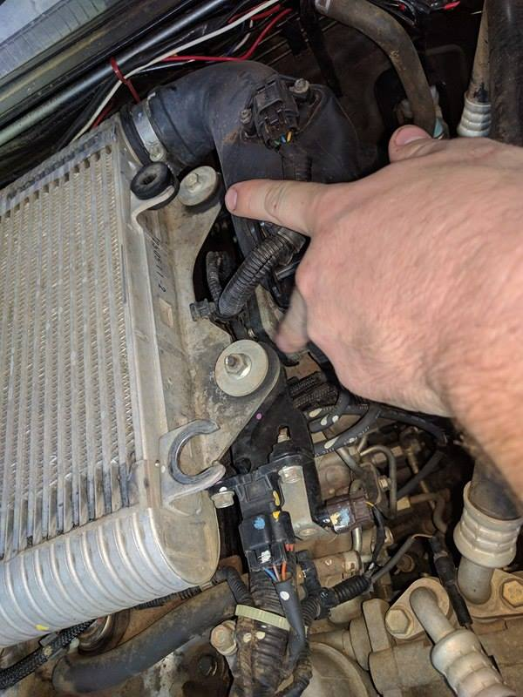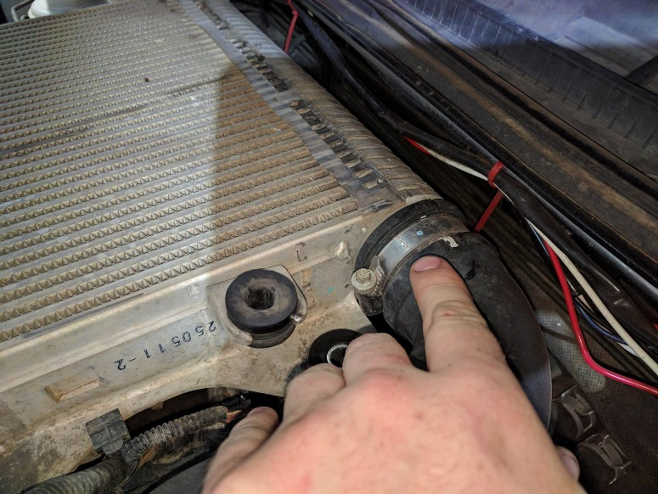

Once the intercooler has been removed you will now see the injectors.
Carefully unplug the factory wiring loom from the injector, don’t pull on wiring!!! (some cars you will need to push in than out)
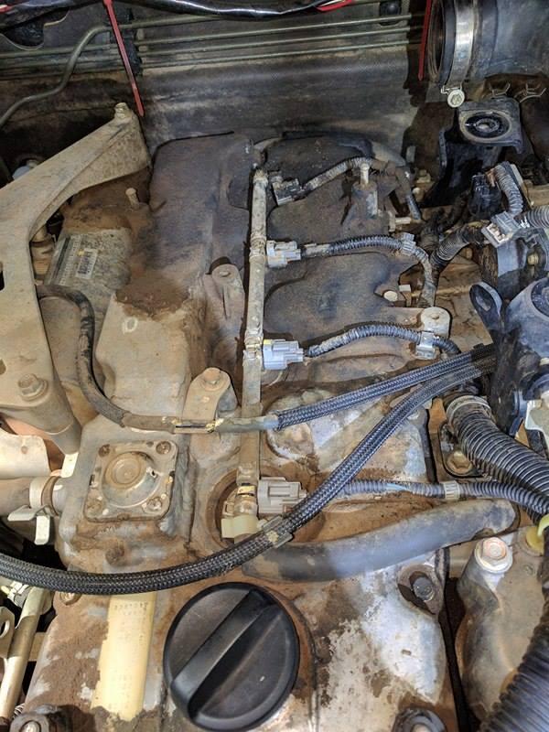

Once you have unplugged the factory injector loom, you will need to run the ECU Torque System wiring harness to the factory injector. When doing, this make sure the loom isn’t being put on something hot or where it will rub through the loom. LEAVE SLACK IN THE LOOM

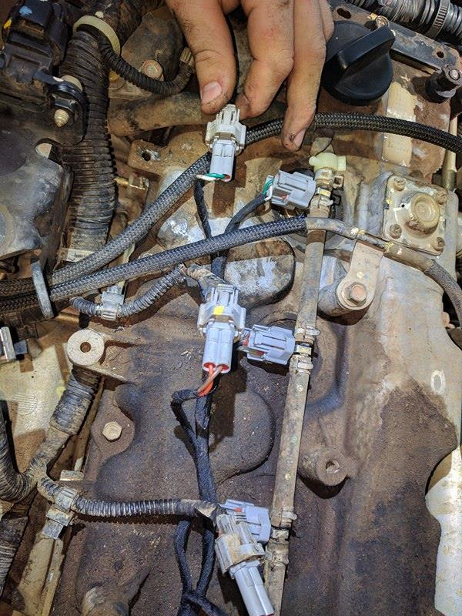
Once you have got the loom to the injectors safely you will need to plug the ECU Torque Loom into the injector, the factory injector plug will than go into the ECU Torque plug (as in photo)
NOTE: The ECU Torque Loom can run front to back or back to front. (DON’T CROSS LOOM)
If plug with green and white wire go to the 1st injector than the male plug with green and white will go to factory injector one loom.

When the injectors are all plugged in right you will than run the MAP Sensor loom to the MAP Sensor (on the intercooler or intercooler piping) LEAVE SLACK IN THE LOOM
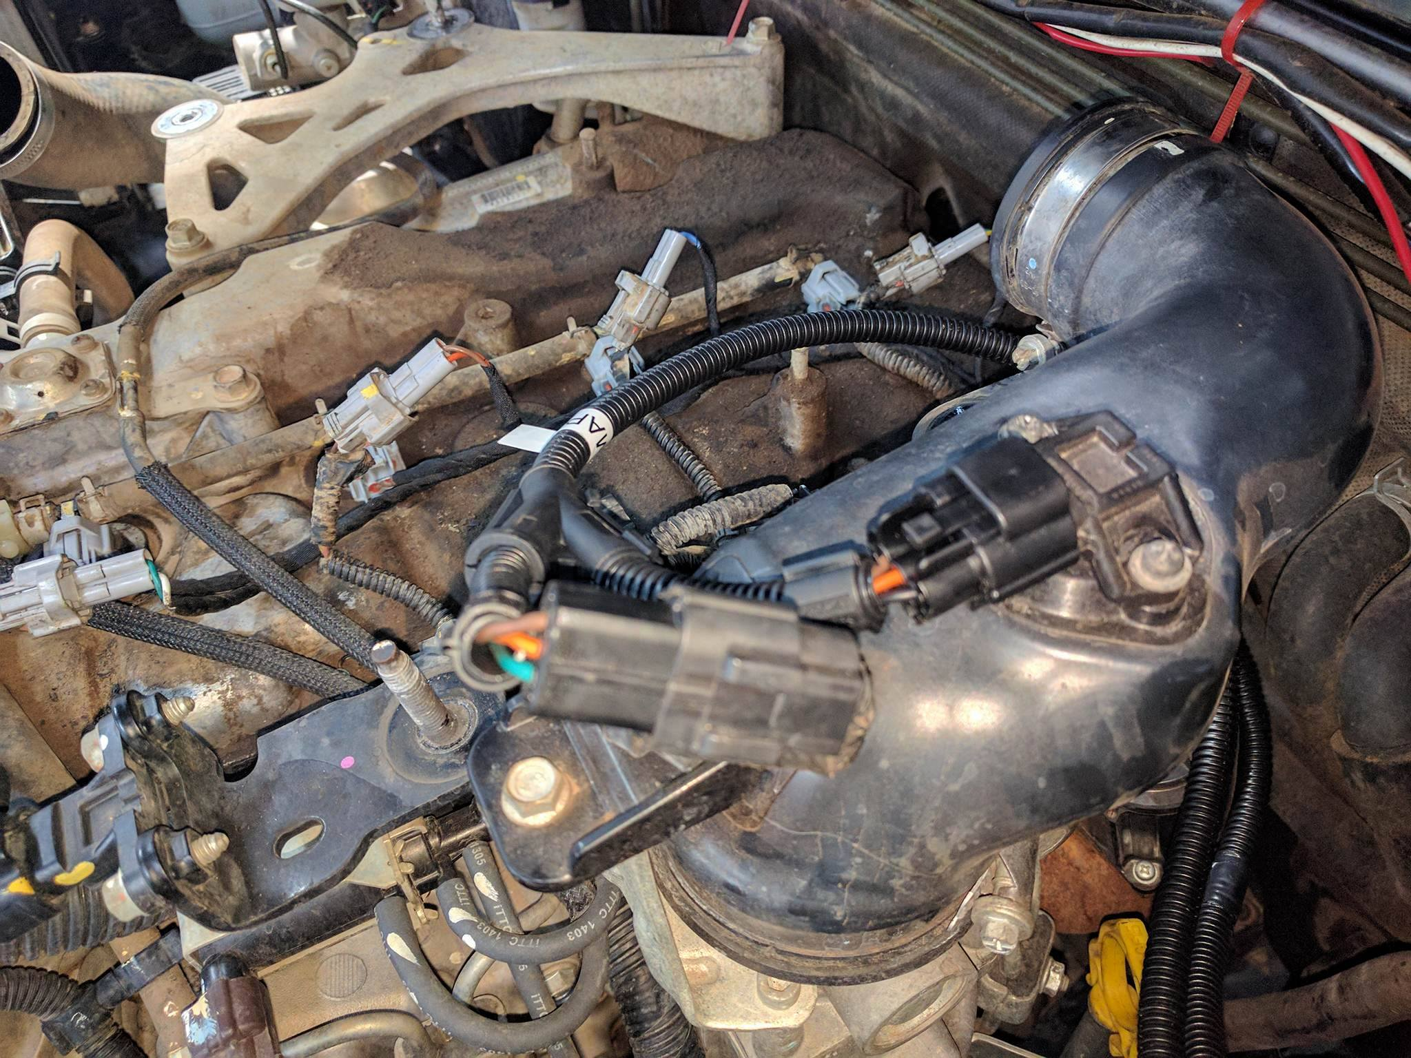

On some cars, you will plug into the commonrail sensor. The easiest way to find the sensor is to follow the injector fuel lines to the commonrail (where the sensor will attached to the commonrail)
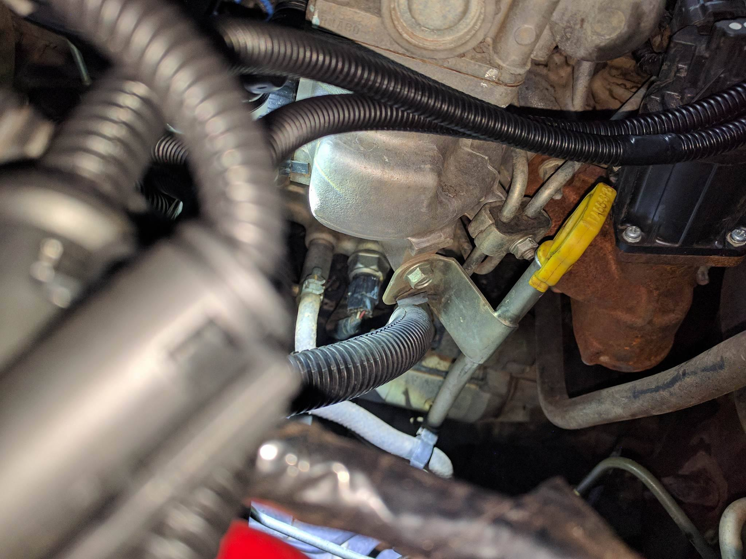

Unplug the factory loom without pulling on the wiring. Once done you will plug the ECU Torque loom into the rail. The male plug on the ECU Torque Loom will go to the factory rail loom.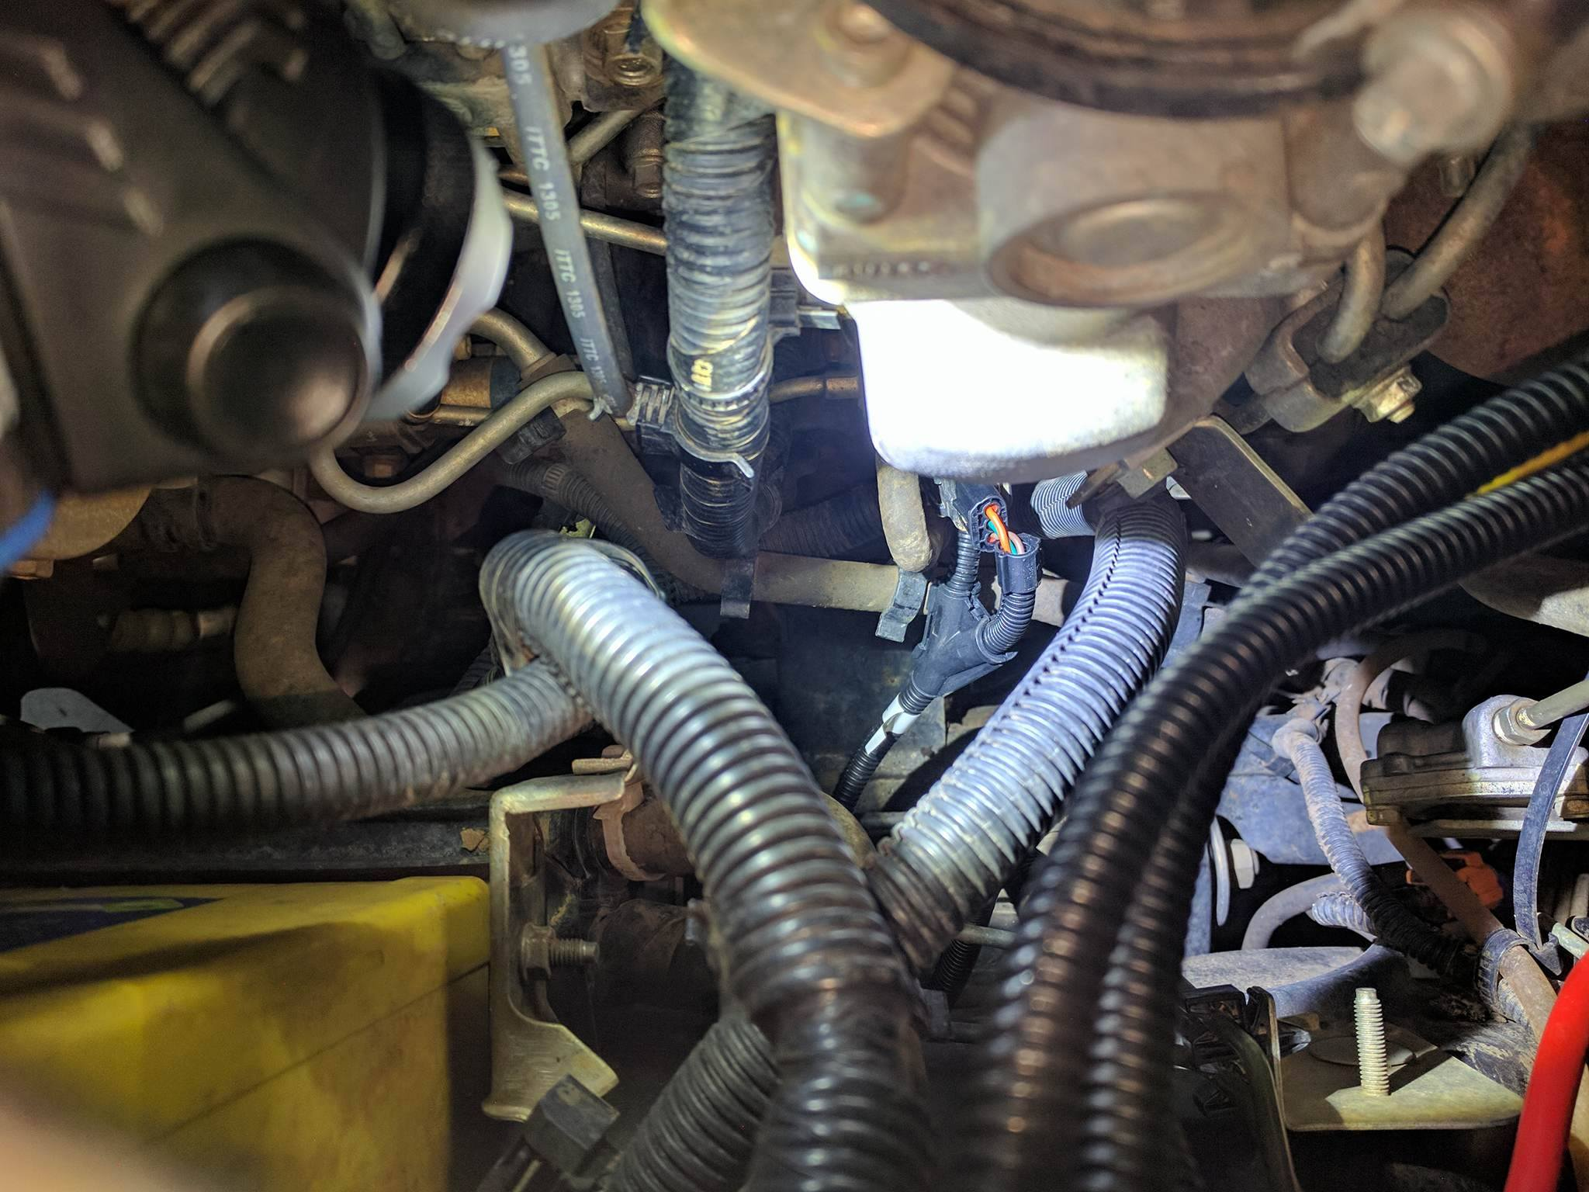

Once the ECU Torque Loom is all in and zip tied up (with some slack for motor pulling) we will now fit the In Cab Tuner

FIRST YOU NEED TO FIND A RUBBER GROMMET ON THE FIREWALL OF YOUR ENGINE BAY (The main wiring harness go through into the cabin of the vehicle). It is preferable to find a small grommet away from the main wiring loom. If you use the grommet as seen in the picture, be careful not to cut/chaff/pierce or short any wires as you route the wiring harness through.
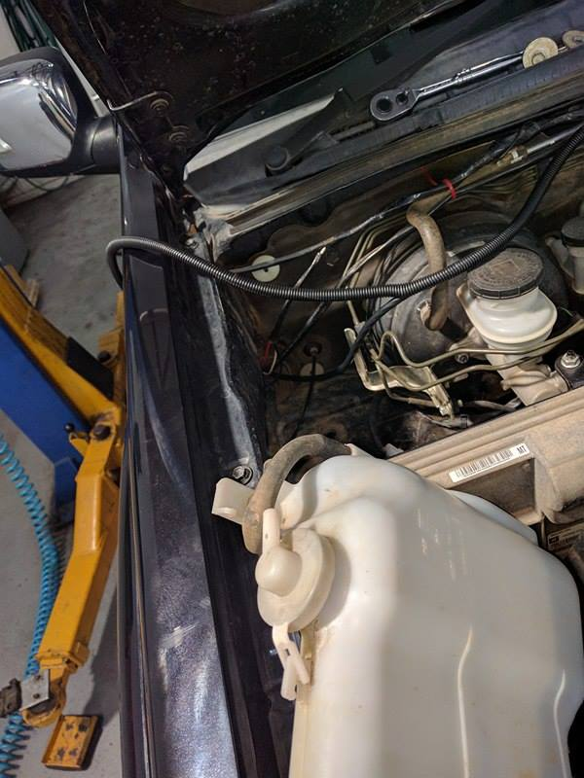
Run the ECU Torque System In Cab Loom to the grommet once done you will need to push the loom through the grommet
NOTE: Silicone spray helps a lot
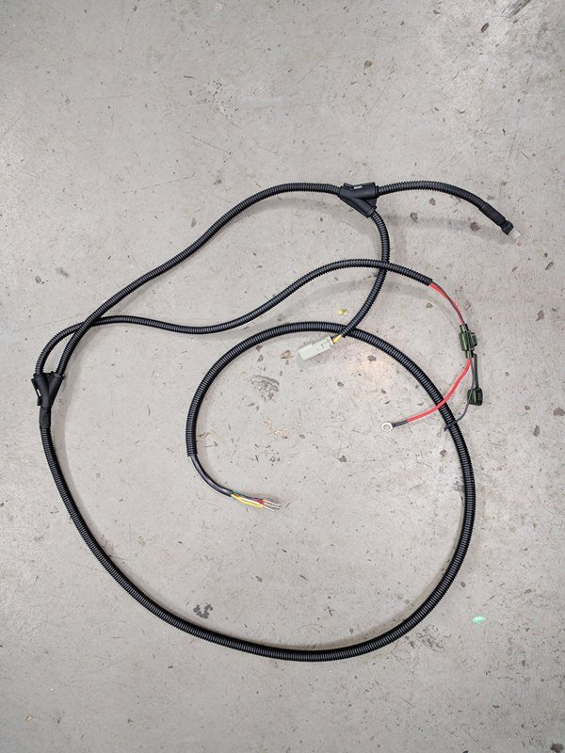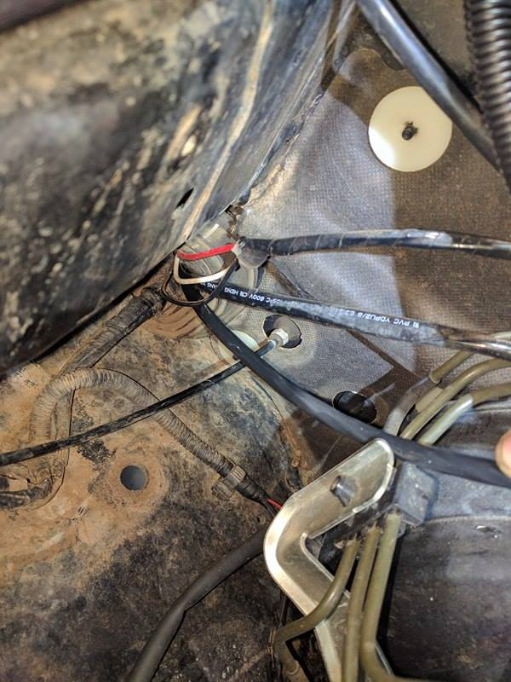

Once the loom is in the cab you will need to find a place for the In Cab Tuner
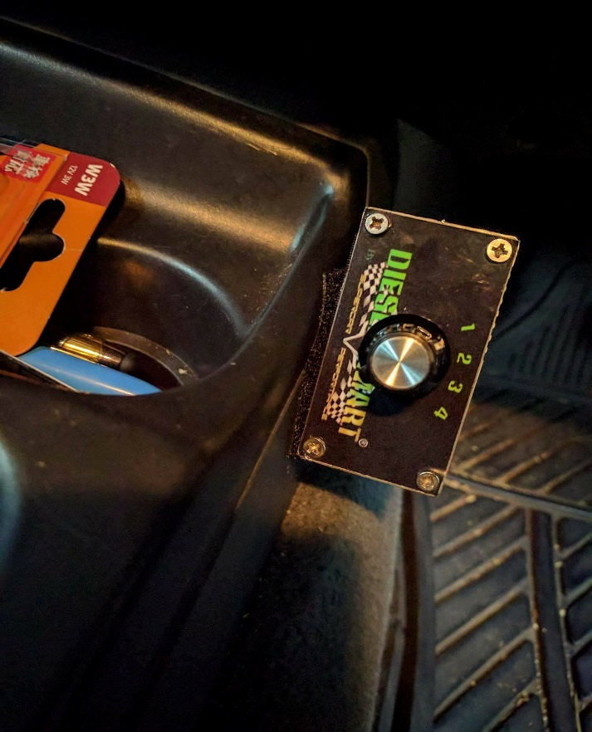

Once you have found a place that suits you will need to pin the 7 wires in the 8 pin plug (colour to colour)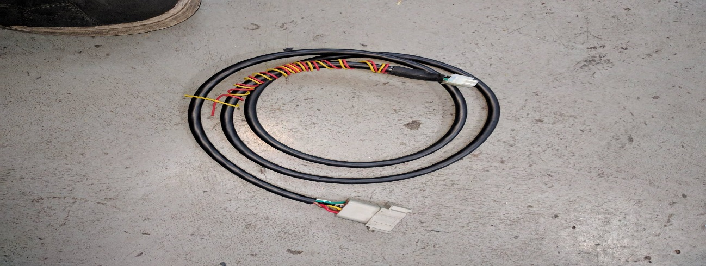

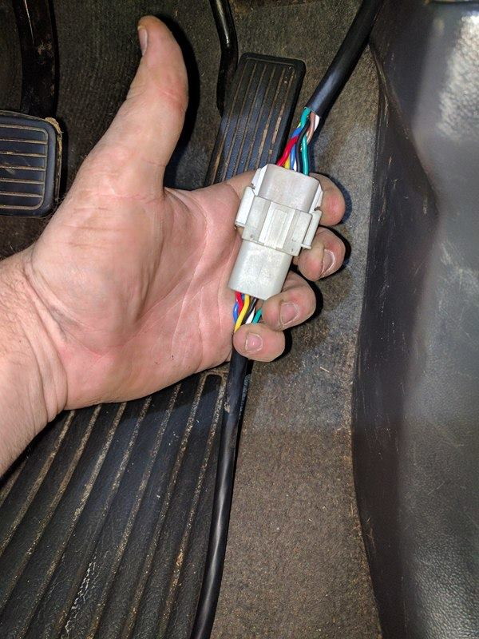

Please double check that the colours are right, zip tie the loom up.

The red and yellow wire will not be used unless we have put a note in the box please cut them short.
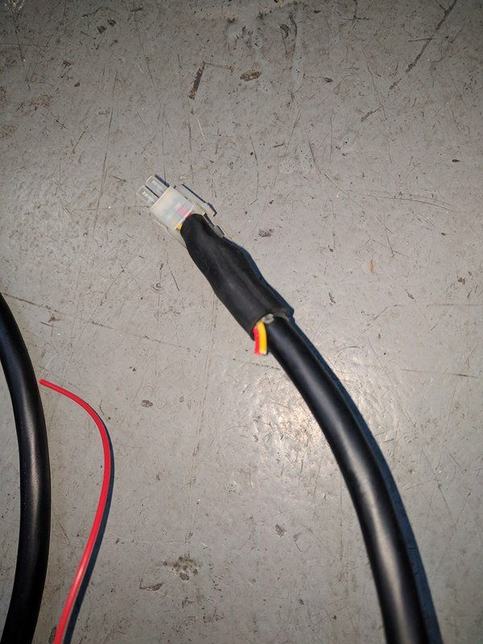

BACK UNDER THE BONNET OF THE CAR

You need to plug in the 2-pin plug from the ECU Torque loom to the in-cab tuner loom. (PLEASE CHECK BLACK IS TO BLACK) if not please contact us. The easiest way to contact us is via our Diesel Smart Facebook page otherwise please call us on 07 49530040.
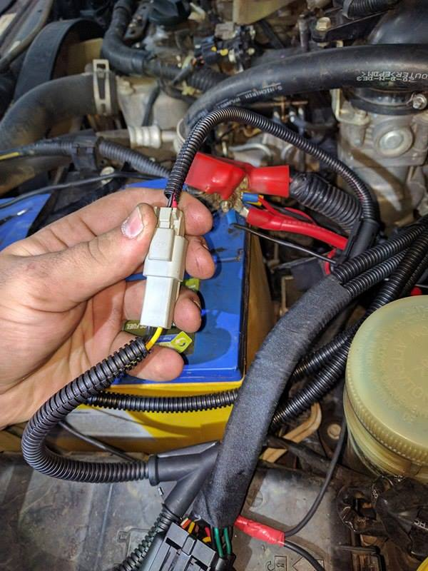

Now we must connect the positive and negative to the MAIN BATTERY with the 5-amp fuse

(HAVE THE BYPASS PLUG IN)
Once the power is connected please turn the key to on and wait for 5 to 8 seconds, once the time is done please start the car.
(HAVE THE BYPASS PLUG IN)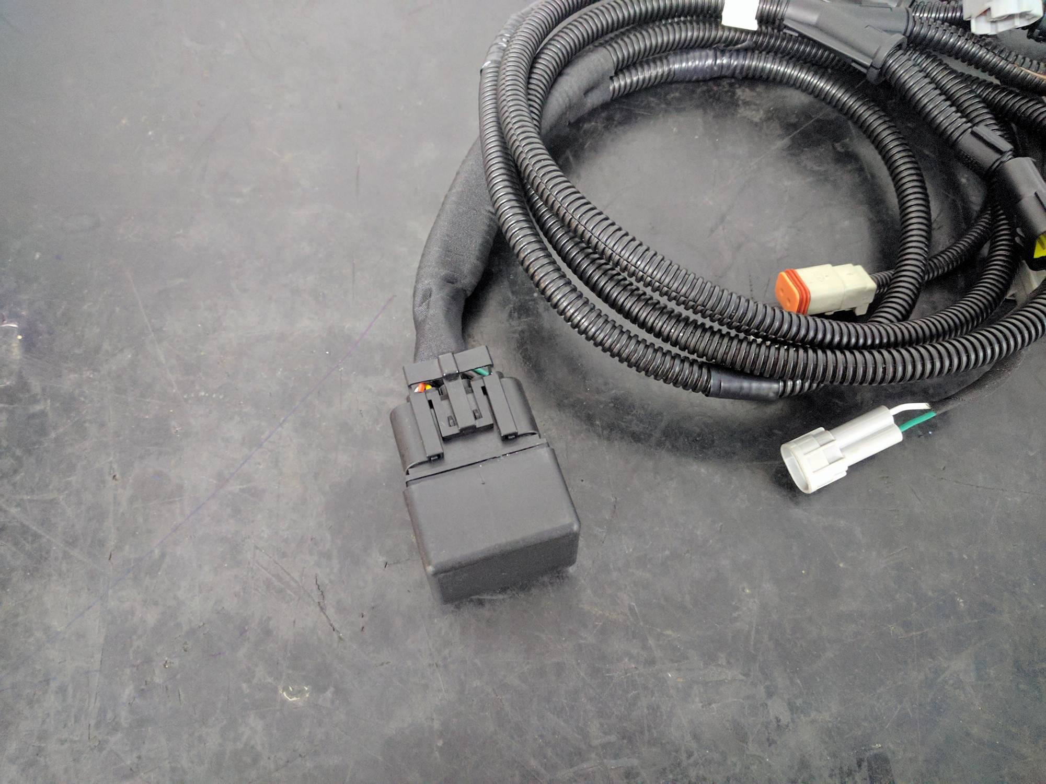

Now that the car has started please check if any lights are on. If all is good plug the ECU Torque System into the wiring harness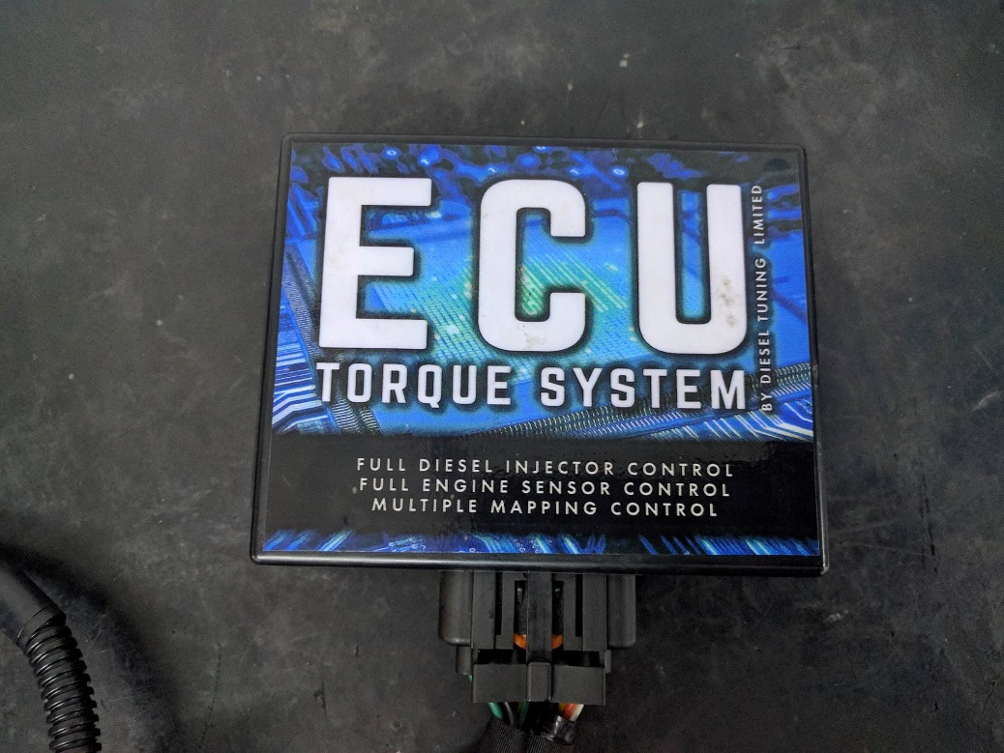

Now we can plug the Switching 4 Pin plug into the ECU Torque System 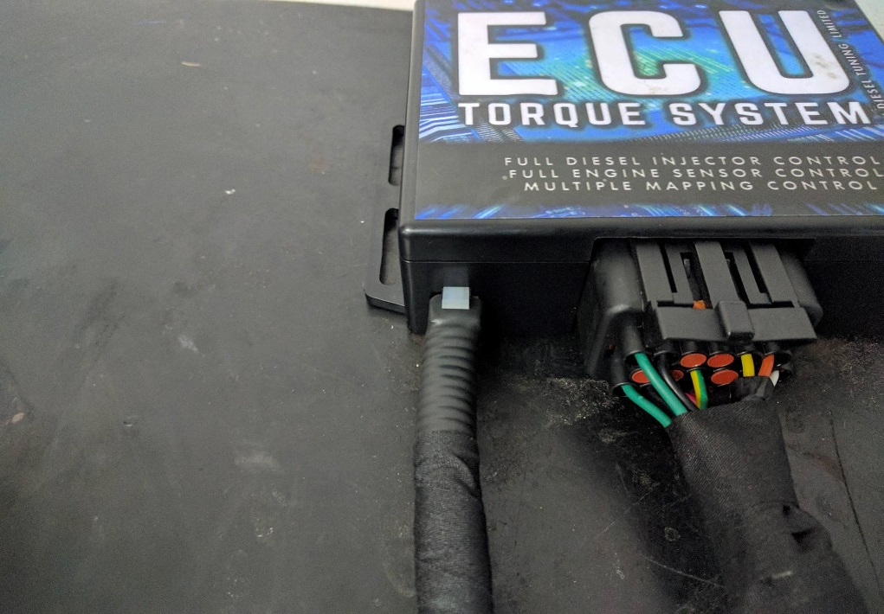

All components of the in-cab tuner system must be plugged in and correctly fitted before turning the key on, or starting the vehicle. If any of the in-cab tuner is not plugged in, the ECU System has no power and can cause the system to fail. This is not covered under warranty.

NOTES
Clean the intercooler piping and where the pipe goes onto the intercooler make sure all oil is off the pipe. (BRAKE CLEANER IS GOOD TO USE)

If pipes blow off use bigger hose clamps.

If there are any questions or you need help with something please facebook us on our Diesel Smart Facebook page or call us (07) 49530040

